**Individual Reflection for AHMAD WAKIL BABAGANA 1820222043 巴戈  
  
Backend Developer for my team**

As the backend developer for the chat application project, I was responsible for creating and maintaining the core functionality of the application, primarily focusing on the server-side logic, database management, and WebSocket integration for real-time communication. Below, I outline the key areas of my involvement, the challenges I faced, and how I collaborated with my team to ensure the smooth execution of the project.

**Role Specialization**

In this project, I specialized in:

* **Backend development with Django**: I structured the models, views, and channels for handling communication between clients posting of messages by users, login and registering interface. Using Django's ORM, I connected the app to SQLite, ensuring proper data management for users and chat history.
* **WebSocket integration**: I used Django Channels and Daphne to handle asynchronous communication, ensuring real-time updates for chat messages.

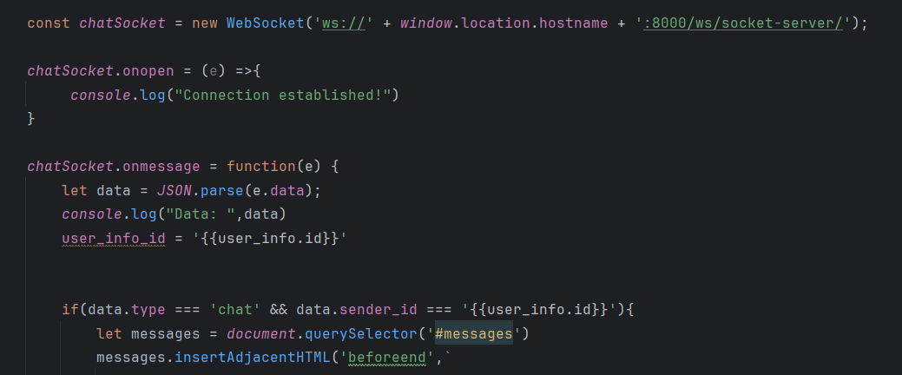

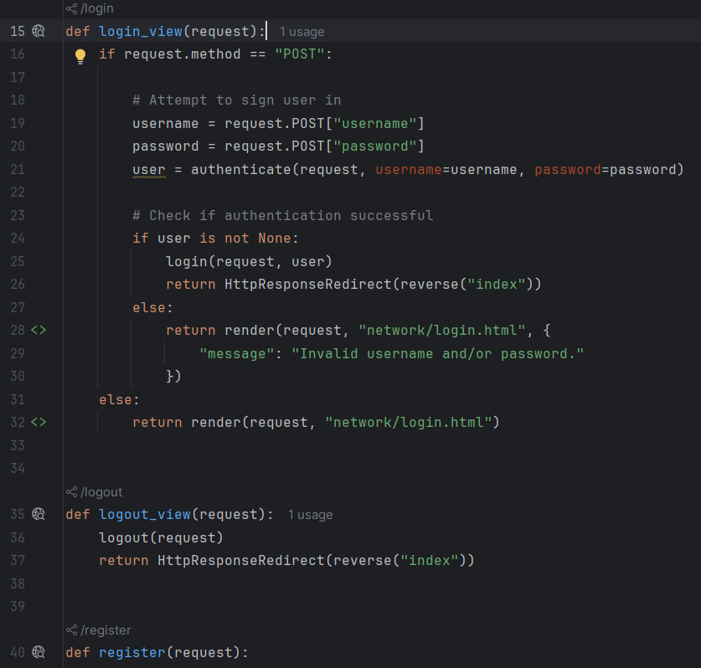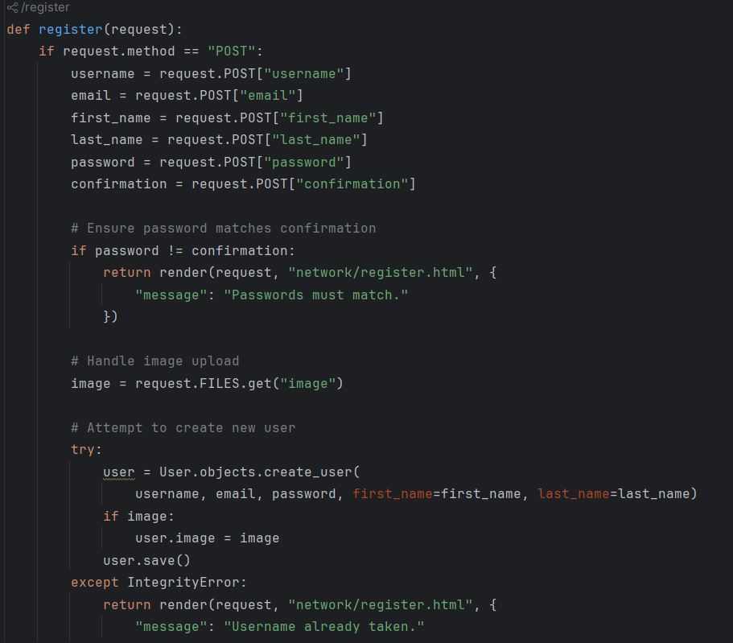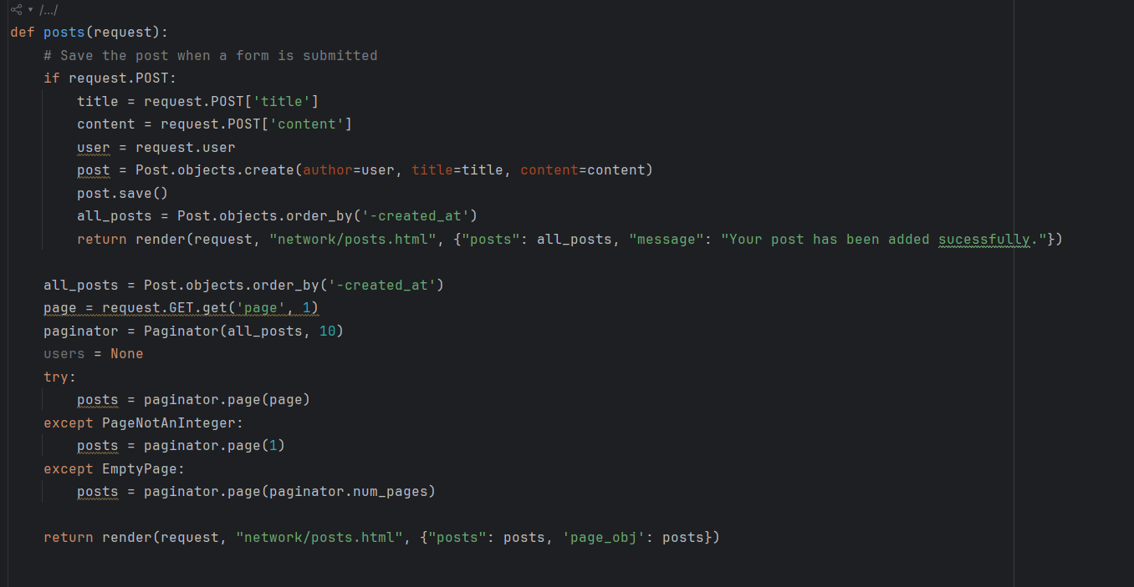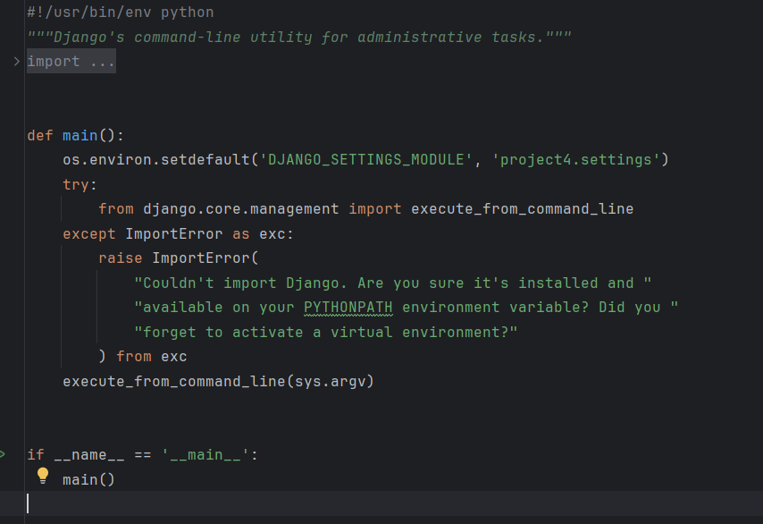

**Key Challenges and Solutions**

* **WebSocket Real-Time Integration**: The integration of WebSocket for real-time chat functionality proved challenging. One issue I encountered was ensuring smooth asynchronous communication between clients without message lag or duplication. By leveraging Django Channels and Daphne, I was able to implement a robust connection mechanism that resolved this.
* **Handling Asynchronous Events**: Since real-time applications require asynchronous functionality, handling and organizing asynchronous events was a technical challenge, especially when dealing with user connections and messages.

**Working as a Team**

The success of this project was not only due to individual efforts but also our cohesive team collaboration. Even though everyone contributed to each tasks we still divided tasks in a way that allowed each of us to focus on our areas of expertise:

* The **frontend developer** ensured the UI/UX design was intuitive and integrated the frontend with the backend APIs.
* The **database manager** worked closely with me to optimize and structure the SQLite database, ensuring that queries were efficient.
* The **websocket integrator & CI/CD Engineer** was crucial in the role of ensuring that the system was well-tested, deployed seamlessly, and integrated with real-time WebSocket functionalities.

Effective communication was key to solving any blockers quickly. We used tools like Git for version control, ensuring that changes to the codebase were tracked and merged seamlessly.

**Overall Performance**

While there were obstacles along the way, I believe I successfully met the expectations of the backend developer role. By coordinating closely with other team members, staying committed to deadlines, and solving technical challenges with well-researched solutions, I contributed significantly to the overall functionality and scalability of the chat application. The experience allowed me to deepen my understanding of Django, WebSockets, and real-time communication, and I look forward to taking on even more complex backend tasks in future projects.